Case 2-Afr-Egy-Apis Bull-Bronze

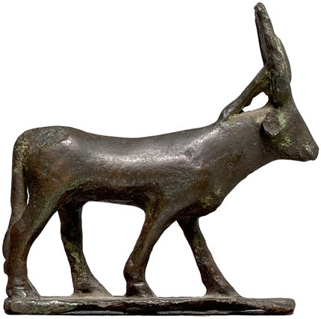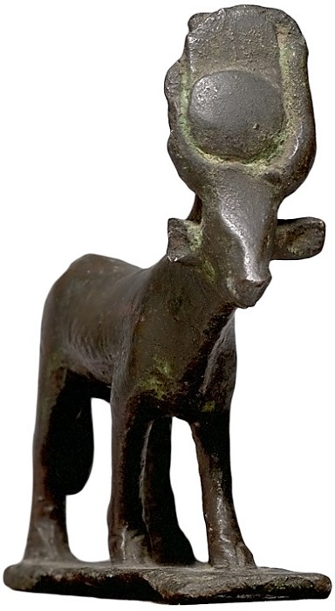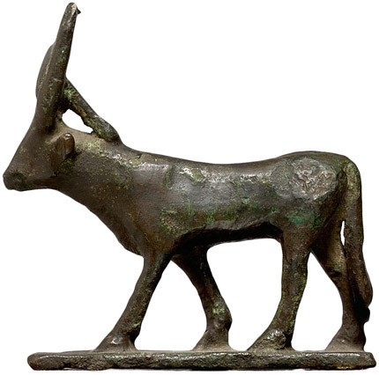

Case No.:

Accession Number:

Formal Label:

**Display Description:**

This ancient Egyptian bronze Apis Bull with a [uraei](http://www.touregypt.net/Uraeus.htm)-kalathos headdress, a cobra in an upright position who was the protector of the king, an agent of his destructive powers symbolized by its spitting fire and a figure associated with the goddess Wadjit.

LC Classification:

Date or Time Horizon:

Geographical Area:

Map:

GPS Coordinates:

Cultural Affiliation:

Medium:

**Dimensions**:   
**Weight:**

**Provenance**:

**Condition:**

**Discussion:**

References:

Berk, Harlan J. Egyptian Bronze Apis Bull **Inv.#** aq17797, **Price:** $4500.